UNIT VII
FET AMPLIFIERS
7.0 INTRODUCTION
Field Effect Transistor (FET) amplifiers provide an excellent voltage gain and high input impedence. Because of high input impedence and other characteristics of JFETs they are preferred over BJTs for certain types of applications.

There are 3 basic FET circuit configurations:
i)Common Source
ii)Common Drain
iii)Common Gain
Similar to BJT CE,CC and CB circuits, only difference is in BJT large output collector current is controlled by small input base current whereas FET controls output current by means of small input voltage. In both the cases output current is controlled variable.
FET amplifier circuits use voltage controlled nature of the JFET. In Pinch off region, I_{D} depends only on V_{GS}.

7.1 Common Source (CS) Amplifier
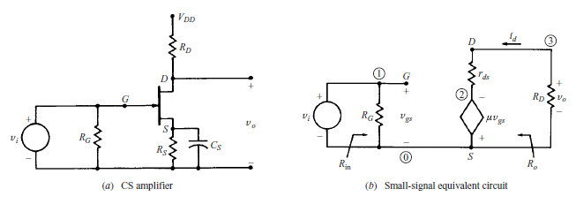
Fig. 7.1 (a) CS Amplifier (b) Small-signal equivalent circuit

A simple Common Source amplifier is shown in Fig. 7.1(a) and associated small signal equivalent circuit using voltage-source model of FET is shown in Fig. 7.1(b)

Voltage Gain
Source resistance (R_{S}) is used to set the Q-Point but is bypassed by C_{S} for mid-frequency operation. From the small signal equivalent circuit ,the output voltage
V_{O} = -R_{D}µV_{gs}(R_{D} + r_{d})
Where V_{gs} = V_{i} , the input voltage,
Hence, the voltage gain,
A_{V} = V_{O} / V_{i} = -R_{D}µ(R_{D} + r_{d})

Input Impedence
From Fig. 7.1(b) Input Impedence is
Z_{i =} R_{G}
For voltage divider bias as in CE Amplifiers of BJT
R_{G} = R₁ ║ R₂

Output Impedance
Output impedance is the impedance measured at the output terminals with the input voltage V_{I} = 0
From the Fig. 7.1(b) when the input voltage V_{i} = 0, V_{gs} = 0 and hence
µ V_{gs} = 0
The equivalent circuit for calculating output impedence is given in Fig. 7.2.
Output impedence Z_{o} = r_{d} ║ R_{D}
Normally r_{d} will be far greater than R_{D} . Hence Z_{o} ≈ R_{D}

7.2 Common Drain Amplifier
A simple common drain amplifier is shown in Fig. 7.2(a) and associated small signal equivalent circuit using the voltage source model of FET is shown in Fig. 7.2(b).Since voltage V_{gd} is more easily determined than V_{gs,} the voltage source in the output circuit is expressed in terms of V_{gs} and Thevenin’s theorem.
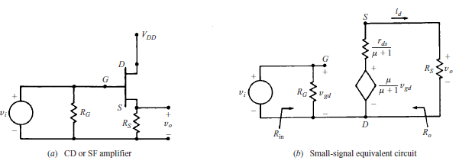
Fig. 7.2 (a)CD Amplifier (b)Small-signal equivalent circuit
Voltage Gain
The output voltage,
V_{O} = R_{S}µV_{gd} / (µ + 1) R_{S} + r_{d}
Where V_{gd} = V_{i} the input voltage.
Hence, the voltage gain,
A_{v} = V_{O} / V_{i} = R_{S}µ / (µ + 1) R_{S} + r_{d}

Input Impedence
From Fig. 7.2(b), Input Impedence Z_{i} = R_{G}

Output Impedence
From Fig. 7.2(b), Output impedence measured at the output terminals with input voltage V_{i} = 0 can be calculated from the following equivalent circuit.
As V_{i} = 0: V_{gd} = 0: µv_{gd} / (µ + 1) = 0
Output Impedence
Z_{O} = r_{d} / (µ + 1) ║R_{S}
When µ » 1
Z_{O} = ( r_{d} / µ) ║R_{S} = (1/g_{m}) ║R_{S}

7.3 BIASING FET:-
For the proper functioning of a linear FET amplifier, it is necessary to maintain the operating point Q stable in the central portion of the pinch off region The Q point should be independent of device parameter variations and ambient temperature variations
This can be achieved by suitably selecting the gate to source voltage VGS and drain current ID which is referred to as biasing
JFET biasing circuits are very similar to BJT biasing circuitsThe main difference between JFET circuits and BJT circuits is the operation of the active components themselves
There are mainly two types of Biasing circuits
- Self bias
- Voltage divider bias.

7.3.1. SELF BIAS:-
Self bias is a JFET biasing circuit that uses a source resistor to help reverse bias the JFET gate.
A self bias circuit is shown in the fig 7.3
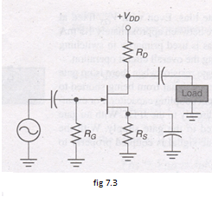
Self bias is the most common type of JFET bias. This JFET must be operated such that gate source junction is always reverse biased. This condition requires a negative VGS for an N channel JFET and a positive VGS for P channel JFET. This can be achieved using the self bias arrangement as shown in Fig 7.3. The gate resistor RG doesn’t affect the bias because it has essentially no voltage drop across it, and : the gate remains at 0V .RG is necessary only to isolate an ac signal from ground in amplifier applications. The voltage drop across resistor RS makes gate source junction reverse biased.
DC analysis of self Bias:-
In the following DC analysis , the N channel J FET shown in the fig7.4. is used for illustration.
For DC analysis we can replace coupling capacitors by open circuits and we can also replace the resistor RG by a short circuit equivalent.
:. IG = 0
The relation between ID and VGS is given by
Id=Idss[1-]²
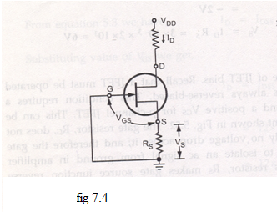
VGS for N channel JFET is =-id Rs
Substuting this value in the above equation
Id=Idss[1-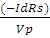]²
Id=Idss[1+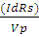]²
For the N-chanel FET in the above figure
Is produces a voltage drop across Rs and makes the source positive w.r.t ground
in any JFET circuit all the source current passes through the device to drain circuit this is due to the fact that there is no significant gate current
therefore we can define source current as Is=Id and Vg=0 then
^{Vs= Is Rs =IdRs}
^{Vgs=Vg-Vs=0-IdRs=-IdRs}
Drawing the self bias line:-
Typical transfer characteristics for a self biased JFET are shown in the fig7.5.
The maximum drain current is 6mA and the gate source cut off voltage is -3V. This means the gate voltage has to be between 0 and -3V.
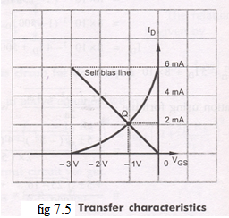

Now using the equation VGS = -IDRS and assuming RS of any suitable value we can draw the self bias line.
Let us assume RS = 500Ω
With this Rs , we can plot two points corresponding to ID = 0 and Id = IDSS
for ID = 0
VGS = -ID RS
VGS = 0X (500.Ω) = 0V
So the first point is (0 ,0)
( I_{d}, VGS)
For ID= IDSS=6mA
VGS = (-6mA) (500 Ω) = -3V
So the 2nd Point will be (6mA,-3V)
By plotting these two points, we can draw the straight line through the points. This line will intersect the transconductance curve and it is known as self bias line. The intersection point gives the operating point of the self bias JFET for the circuit.
At Q point , the ID is slightly > than 2mA and VGS is slightly > -1V. The Q point for the self bias JFET depends on the value of Rs.If Rs is large, Q point far down on the transconductance curve ,ID is small, when Rs is small Q point is far up on the curve , ID is large.

7.3.2 VOLTAGE DIVIDER BIAS:-
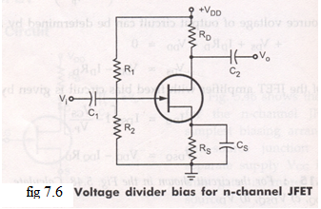
The fig7.6 shows N channel JFET with voltage divider bias. The voltage at the source of JFET must be more positive than the voltage at the gate in order to keep the gate to source junction reverse biased. The source voltage is
VS = IDRS
The gate voltage is set by resistors R1 and R2 as expressed by the following equation using the voltage divider formula.
Vg=Vdd
For dc analysis fig 7.7
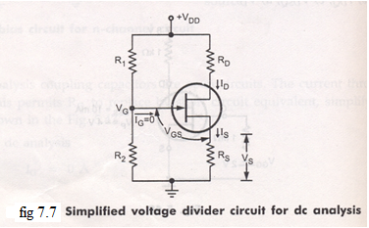

Applying KVL to the input circuit
VG-VGS-VS =0
:: VGS = VG-Vs=VG-ISRS
VGS = VG-IDRS :: IS = ID
Applying KVL to the input circuit we get
VDS+IDRD+VS-VDD =0
::VDS = VDD-IDRD-IDRS
VDS = VDD-ID ( RD +RS )
The Q point of a JFET amplifier , using the voltage divider bias is
IDQ = IDSS [1-VGS/VP]2
VDSQ = VDD-ID ( RD+RS )

7.4 JFET AS A VVR OR VDR:-

Let us consider the drain characteristics of FET as shown in the fig.
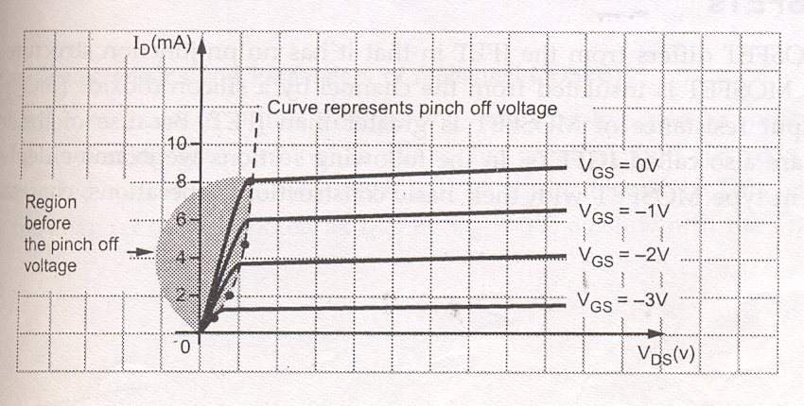
In this characteristics we can see that in the region before pinch off voltage, drain characteristics are linear, i.e. FET operation is linear. In this region the FET is useful as a voltage controlled resistor,i.e. the drain to source resistance is controlled by the bias voltage VGS.( In this region only FET behaves like an ordinary resistor This resistances can be varied by VGS ) .The operation of FET in the region is useful in most linear applications of FET.In such an application the FET is also referred to as a voltage variable resistor (VVR) or voltage dependent resistor (VDR).
The drain to source conductance ( rd )
g_{d}= for small values of VDS which may also be expressed as
g_{d}=g_{d0}(1-)^{1/2})
Where g_{d0} is the value of drain conductance
When the variation of the rd with VGS can be closely approximated by the expression
rd=) Where ro = drain resistance at zero gate bias.K = a constant, dependent upon FET type.

7.4.1 APPLICATION OF VVR
The VVR property of FET can be used to vary the voltage gain of a multistage amplifier A, as the signal level is increased. This action is called AGC automatic gain control. A typical arrangement is shown in the fig.
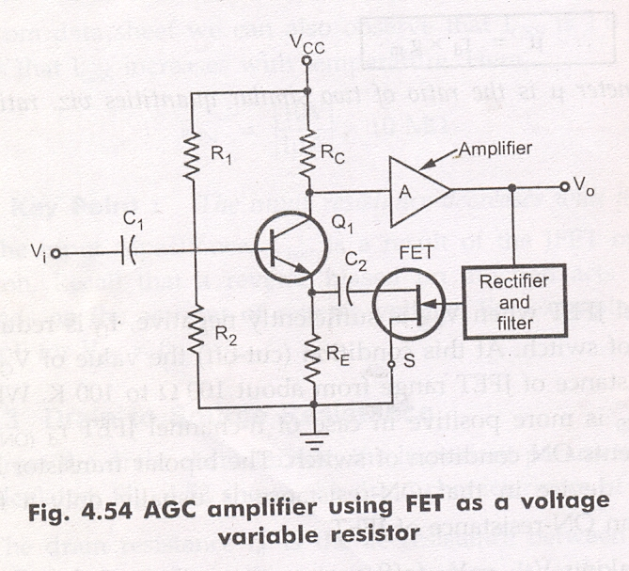
Here maximum value of signal is taken rectified; filter to produce a DC voltage proportional to the output signal level. This voltage is applied to the gate of JFET, this causing the resistance between drain and source to change. As this resistance is connected across RE, so effective RE also changes according to change in the drain to source resistance. When output signal level increases, the drain to source resistance rd increases, increasing effective RE. Increase in RE causes the gain of transistor Q1 to decrease, reducing the output signal. Exactly reverse process takes place when output signal level decreased.
:: The output signal level is maintained constant. It is to be noted that the DC bias conditions of Q1 are not affected by JFET since FET is isolated from Q1 by capacitor C2

7.5 UNI JUNCTION TRANSISTOR (UJT)
Another device whose construction is similar to that of the FET is shown in the figure.
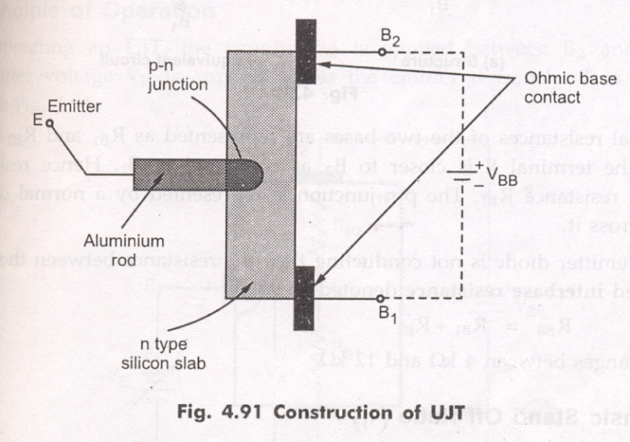

It is a three terminal device, having two layers.It consists of a slab of lightly doped N-type silicon material. The two base contacts are attached to both ends of this N-type surface. These are denoted as B1 and B2 respectively.
A P-type material is used to form a pn junction at the boundary of the aluminium rod and N-type slab. The N-type is lightly doped while P-type is heavily doped. That is N-type provides high resistivity and P-type provides low resistivity.
This device was originally described in the literature as the double-base diode, but is now commercially available under the designation Uni Junction transistor (UJT).
The standard symbol for this device is shown in the fig.
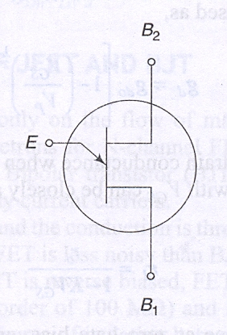
Here the emitter arrow is inclined and points toward B1 and This emitter arrow which is at an angle to the vertical line representing N-type material. This arrow indicates the direction of flow of conventional current when UJT is forward biased.

EQUIVALENT CIRCUIT OF UJT
The circuit of UJT is shown in the fig.
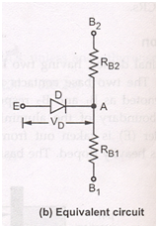
In the construction ,the terminal emitter is closer to B₂ as compared to B_{1.}
If we see the equivalent circuit of UJT, The internal resistances of the two bases are represented as R_{b1}and R_{b2}. Hence R_{b1} is greater than R_{b2}. The pn junction is represented by a normal diode with V_{d} as the drop across it. When the emitter diode is not conducting then the resistance between the two bases B₁ and B₂ is called interbase resistance denotes R_{bb}
R_{bb}=R_{b1}+R_{b2}
Its value ranges from 4kΩ to 12kΩ

Intrinsic stand off ratio (η)
Consider UJT as shown in the fig. to which supply V_{bb} is connected. With I_{e}=0, That is emitter diode is not conducting ,
R_{bb}=R_{b1}+R_{b2}
Then the voltage drop across R_{b1} can be obtained by using potential divider rule.
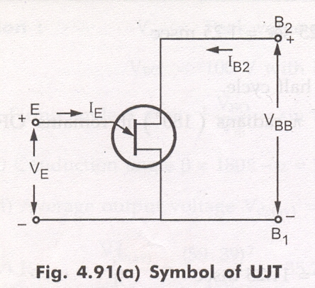

Replacing with its equivalent circuit
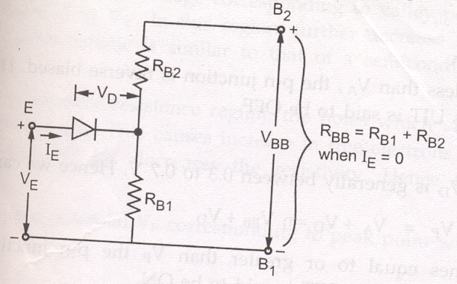

R_{bb}=R_{b1}+R_{b2}
When I_{e} =0
V_{RB1}=) V_{BB} = η.V_{BB} When I_{e}=0
η = Intrinsic stand off ratio =) when Ie=0
η =) when I_{e}=0
The value of η is from 0.5 to 0.8 the voltage V_{rb1} is called intrinsic stand off voltage, because it keeps the emitter diode reverse biased for all emitter voltages less than V_{rb1.}
Operation
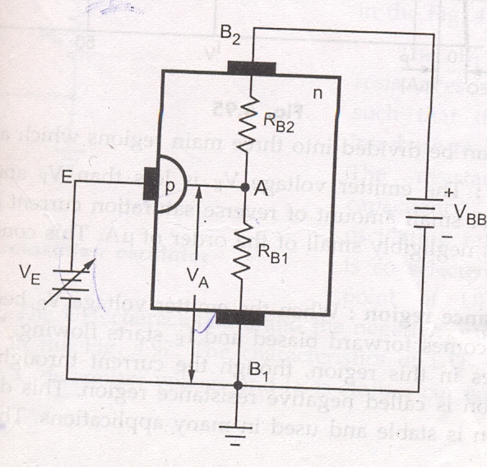

1.The supply V_{bb} is applied between B₂ and B₁ .
2. Variable emitter voltage V_{e} is applied across the emitter terminals.
3. If V_{e} is varied , potential of A is decided by η and is equal to ηV_{bb}
V_{a}=V_{rb1}= ηV_{bb}
Case 1: If V_{e}< V_{a}
As long as V_{e} < V_{a}, the pn junction is reverse biased. Hence emitter current I_{e} will not flow. Thus UJT is said to be off.
Case 2: if V_{e}>V_{p}
The diode drop V_{d} is generally between 0.3 to 0.7v.
We can write V_{p}=V_{a}+V_{d} = ηV_{bb}+V_{d}
When V_{e} becomes equal to or greater than V_{p} the pn junction becomes forward biased and current I_{e} flows. Thus UJT is said to be ON.

VI Characteristics
1.The graph of I_{e} against emitter voltage plotted for a particular value of V_{bb} is called the characteristics of UJT.

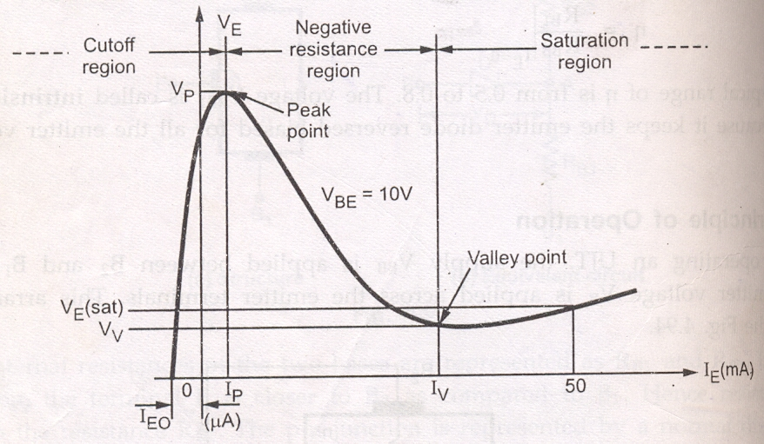

The characteristics can be divided in to three main regions.
1.cut off 2. Negative resistance region 3. Saturation region.
1.cut off: The V_{e}< V_{p} and the pn junction is reverse biased . A small amount of reverse saturation current I_{e0} flows through the device which is negligibly small of the order of micro amps. This condition remains till the peak point.
2. Negative resistance region: When emitter voltage V_{e} becomes equal to V_{p} then p n junction becomes forward biased and I_{e} starts flowing. The voltage across the device decreases in this region though the current through the device increases. Hence the region is called negative resistance region. This decreases the resistance R_{b1}. This region is stable and used in many applications. This region continues till valley point.
3. Saturation region: The region to the right of the valley point is called saturation region. In the valley point, the resistance changes from negative to positive. The resistance remains positive in the saturation region.
As V_{bb} increases , the potential V_{p} corresponding to peak point will increase.

Applications of UJT
The UJT is mainly used in the triggering of other devices such as SCR. It is also used in the sawtooth wave generators and some timing circuits. The most popular application of UJT is as a relaxation oscillator to obtain short pulses for triggering of SCRs.
The relaxation oscillator using UJT which is ment for generating sawtooth waveform. It consists of a UJT and a capacitor , which is charged through emitter resistor as the supply voltage V_{bb} is switched 0N.

